Surplus Update
Surplus
The surplus team has notified Asset Management that there is an active integration that is now communicating between the Surplus’s Property System (SPS) and the Workday System. Once an asset gets picked up by the surplus team, their surplus integration system should dispose of the workday asset. Asset tags should remain affixed for any trackable assets subject to surplus.

Surplus’s integration identifies the workday asset ID that needs to be disposed based off both the asset tag number and serial number supplied on the surplus disposal request. The workday field asset identifier would be the tag number.

Please Note: For assets to successfully be disposed in workday by surplus’s integration, it is integral that both the Tag# and Serial# provided for each asset on the surplus disposal request matches up exactly with what was entered in the workday system. These two asset attributes must reconcile with one another in both systems (surplus property software and workday system) for the integration to work.
The surplus field (“Tag#”) should tie to the workday field (“Asset Identifier”) and the surplus field (“Serial#”) should tie to workday field (“Serial Number”).

(Below, we have included a screenshot of some of the surplus system’s disposal request fields)
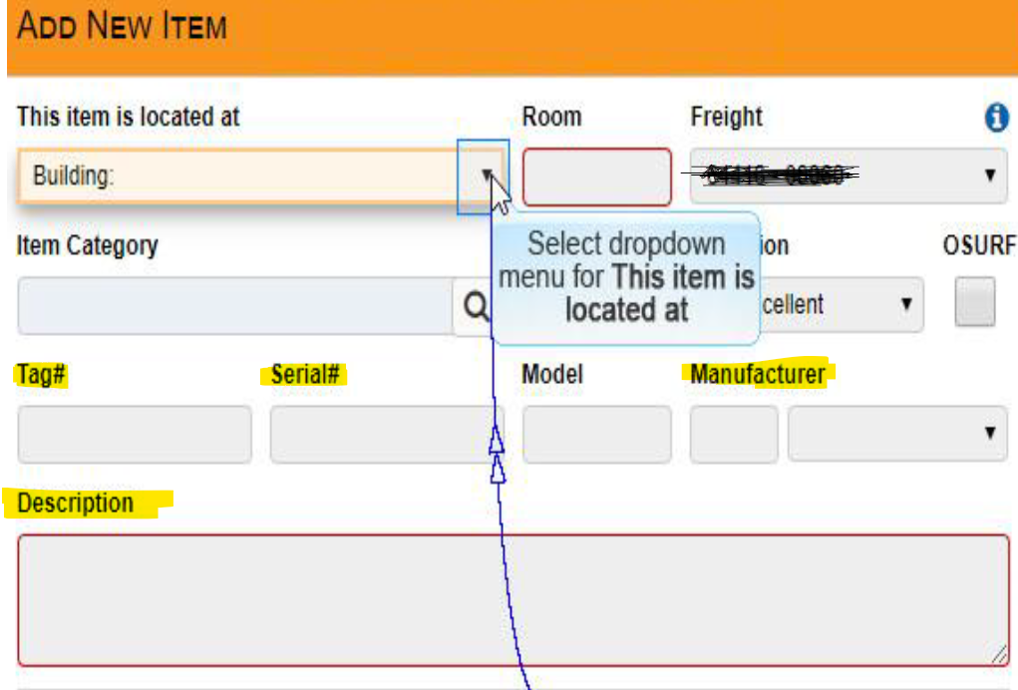

We want to request that all surplus system disposal submitters include an itemized listing of all trackable assets that are subject to surplus. For example, if there are 10 laptops getting surplused, the surplus submitter should be filling out the 4 fields highlighted in yellow above for each of the 10 laptop assets in the surplus system.
At the minimum, we would like to see the Tag#, Serial#, Manufacturer, and Description surplus fields being filled out for each individual trackable item being surplused.
Surplus Team Contacts
If you have any additional questions regarding the surplus integration, please contact Spencer Crawford (crawford.567@osu.edu) and Mike Runyan (runyan.33@osu.edu) from the surplus team.

Tech Hub Update

Tech Hub purchases have started going through the invoicing process. Any Tech Hub orders placed on 10/1/2023 and onwards should have workday invoice workflows created for them which will route to Asset Management for review. Asset Management will create assets from Tech Hub invoices that are processed

*Please do not make manual registrations for any new Tech Hub orders since invoice workflows will eventually route to Asset Management to create the asset records. On the workday requisitions, please use spend category SC10399 for any IT items ordered. This will ensure an invoice to route to Asset Management’s workday inbox once it is processed.

Please Note: Tech Hub purchases that were made prior to October 2023 should have been manually registered by CCATS in Workday.

