Viewing EDI voucher information in PeopleSoft Procurement Inquiry
To search vouchers posted against a Purchase order, begin by entering the PO number in Purchase Order Document Status

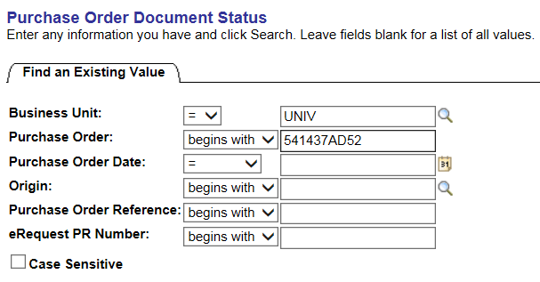
The Search results include requisitions, voucher, payment and eRequest if applicable tied to the PO.
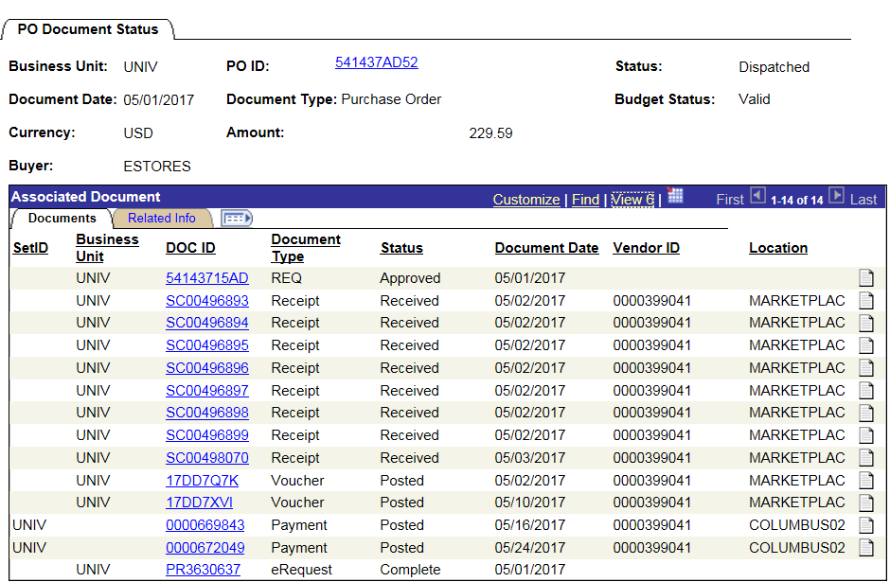
Select the voucher ID 17DD7XVI to view details.

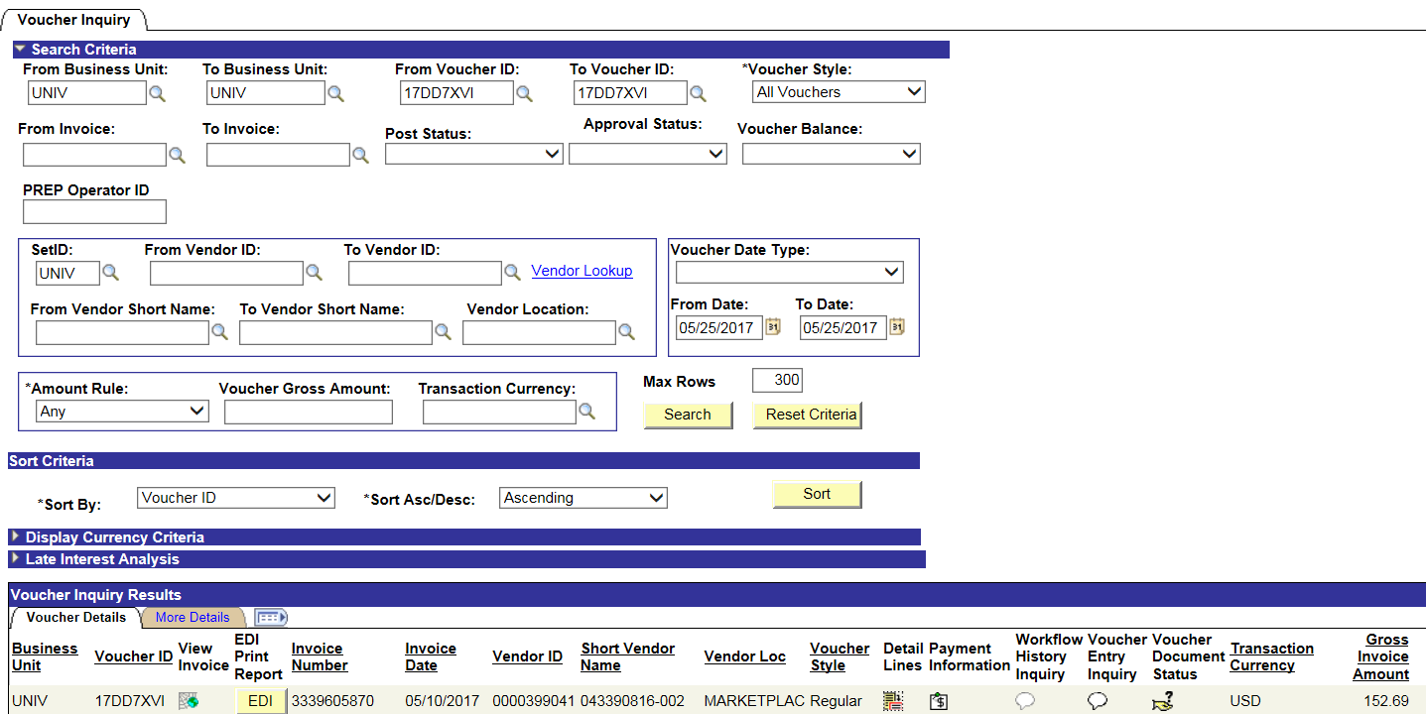

There are two options for viewing line details on EDI vouchers:
Select the Detail Lines icon to view details as shown below or select the yellow EDI button to see the information in a printable report

