**Sources and Uses – Variance Analysis Upcoming Changes.**

Based on user feedback Sources and Uses – Variance Analysis is being updated to provide greater flexibility and insights into Encumbrances. New columns are being added to the report alongside the existing plan to actuals variance calculations which will allow the inclusion of encumbrances numbers in the comparison. Additionally, new dynamic column headings will be added to the report to provide greater clarity to the values in the Plan and Forecast columns based on selections made at report runtime.

These changes are scheduled to be moved to production on: **October 7th 2024.**

Below you will find a bullet point summary of these changes. Please see page two of this document for detailed explanations, as well as before and after screenshots for each change.

Questions or concerns with these updates can be sent to [ctl-businessprocesses@osu.edu](mailto:ctl-businessprocesses@osu.edu).

1. “Plan” and “Forecast” column headings will now update dynamically based on the Budget Plan Name and Forecast Plan Name selected at report runtime.
2. Encumbrances and Pre-encumbrances will no longer be shown at the bottom of the report but have been added as two columns to be shown in line with actuals.
   * This will allow users to view encumbrances by ledger account in line with their actuals and perform more detailed evaluations.
3. To accommodate the relocation of Encumbrances and allow greater analysis, three additional new columns will be added (see second section for detailed explanations and examples).
   * Total with Encumbrances: This column will add Actuals and Encumbrances horizontally across the report.
   * Variance with Encumbrances $: This column will show the variance between your Plan, and total actuals plus encumbrances in dollars.
   * Variance with Encumbrances %: This column will show the variance between your Plan, and total actuals plus encumbrances as a percentage.
4. Ending Equity After Pre Encumbrance and Encumbrance will no longer be displayed on the left bottom of the report but will now be located at the bottom of the new “Total with Encumbrances” column were it intersects with the “Ending Equity” row.

**Sources and Uses – Variance Analysis: Detailed Changes with Screenshots:**

Below you will find detailed explanations, with before and after screenshots for the upcoming changes. Note that for ease of screenshots the ledger account expansions have been collapsed prior to taking the screenshot, the report will continue to render expanded by ledger account by default after these changes have been made. That functionality will not be changed.

1. “Plan” and “Forecast” column headings which are static in the current report will now update dynamically based on the Budget Plan Name and Forecast Plan Name selected at report runtime.

**Current State Plan and Forecast Labels:**

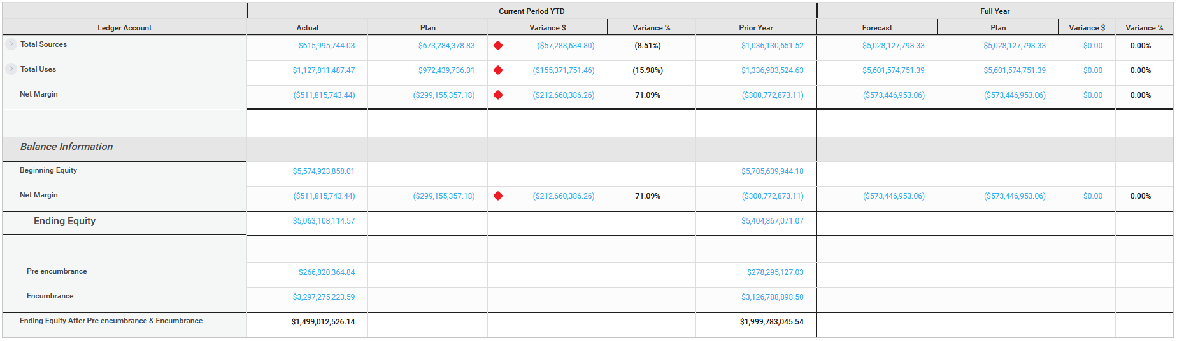

**Future State Plan and Forecast Labels:**

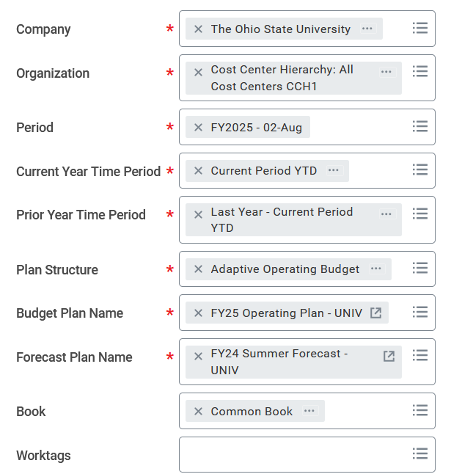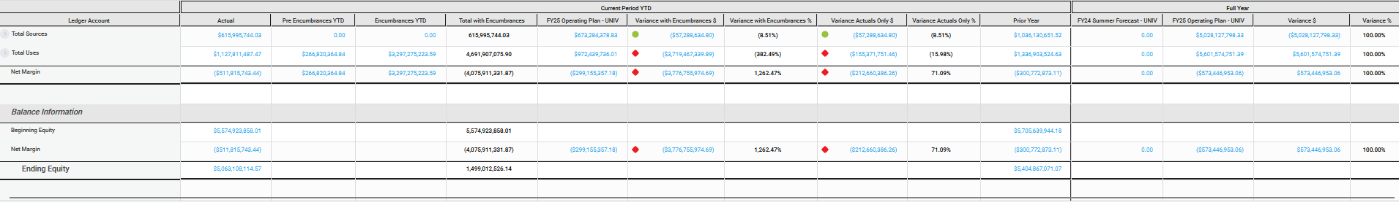

1. Encumbrances and Pre encumbrances will no longer be shown at the bottom of the report but have been added as two columns to be shown in line with actuals.
   * This will allow users to view encumbrances by ledger account in line with their actuals and perform more detailed evaluation.

**Current State Encumbrance Placement:**



**Future State Encumbrance Placement:**

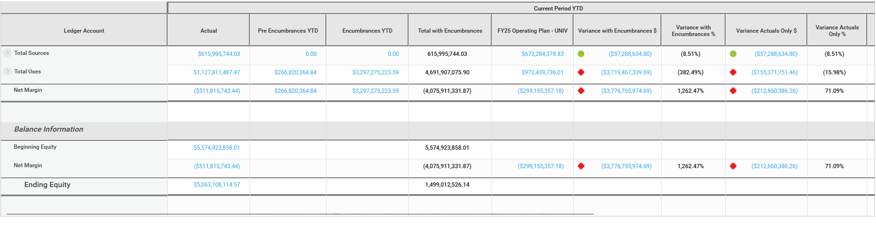

1. To accommodate the relocation of Encumbrances and allow greater analysis; three additional new columns will be added as detailed below. Note: since these columns are new, there is no current state screenshot.
   * Total with Encumbrances: This column will add Actuals and Encumbrances horizontally across the report.
   * Variance with Encumbrances $: This column will show the variance between your Plan, and total actuals plus encumbrances in dollars.
   * Variance with Encumbrances %: This column will show the variance between your Plan, and total actuals plus encumbrances as a percentage.

**Future State Additional Encumbrance Columns:**



1. Ending Equity After Pre Encumbrance and Encumbrance will no longer be displayed on the left bottom of the report but will now be located at the bottom of the “Total with Encumbrances” column at the intersection with the “Ending Equity” row.

**Current State:**



**Future State:**

